RNAseq Analysis
RNAseq/CUT&RUN Pipeline Commands
General linux commands:
- “cd” will change the directory to wherever you want to go
- “ls” will list all the files/directories in the current directory that you’re in
- “pwd” will show you the entire file path for the directory you’re currently in
- “cntrl c” ends any command that is in process
- “ls -l” give u more info about a file and file size
- “ls -lh” for directory size
- “rm” deletes files
- “cp” copy
- “vim” to go into a script/or view a script
- “cd ..” is to go backwards (out of 1 directory)
- “df -h” is to find the statistics of the server (useful when you think there is no space. Check ‘data’ category)
- “clear” will clear the screen
- cp <from path> <to path>
- mv <from path> <to path>
- “mkdir” will make a directory
- “rm -r” remove directory. ONLY USE ON erroneous STARtmp files
- “ ; ” break in line of code
Script Editor: (press “esc”) first
- “G” to go to bottom
- “gg” to go to top
- “ZZ” to exit vim and save and quit
- Shift “I” how you change/edit the script
- Esc-button – exits the edit mode
- “:q!” exit vim without saving
Screen:
- “screen -S“ then a screen name to create a new screen
- ctrl a + d to detach from screen
- ctrl a + k → y to kill a screen
- “screen -ls” to list a screen
- “screen -r [screen.name]” to reattach the screen
  - If multiple screens and want to reattach, then have to type in the full name
- “screen -x [screen.name]” to view attached screen
- “screen -S [screen.name] -X quit” to kill a specific screen

FTP Login
Username: ferguson
Password: bjHl5OPB3C

Before Starting (only need to do the first time):
- Download the PEM key (get it from someone who has it and store it in a folder (if you want)).

Login on AWS:
- Login on AWS
- Sign in using IAM login
  - Account Number: 433642023207
  - Username: FirstnameLastname
  - Individual Accounts
- KellyWang
- au0Cu0)0
- Click on EC2
- Go to Instances (running)

Root user login:
- Username:
cferguson@health.ucsd.edu
- Password:
OKMbhuTFC47$&
^ not used for access to AWS as of 2025

Entering the Instance
- Open terminal on your computer.
- On terminal, change the directory to wherever the PEM key is:
  - cd [DRAG AND DROP FOLDER W/KEY]
  - hit enter
- Open the pem key by typing “chmod 400 210323.pem"
- In the next line, enter “ ssh -i ./210323.pem ubuntu@ec2….com ”
  - Copy the “ec2…” address on AWS.
  - The ec2 address will change after every time someone starts and stops the instance
  - After the “@” is where you paste the new/public ec2 address.
  - Change according to the ec2 line above, copy up to com.
  - Select “yes” to continue connecting.
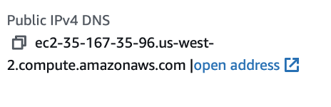

STEP 1: Import fastq files into the instance
- To import files into the instance, you have to be logged out of the instance
  - To logout type “logout”
- For MOUSE FILES: The import command is: “ scp -r -i ./210323.pem path/to/‘fastq file’ ubuntu@ec2-35-88-77-234.us-west-2.compute.amazonaws.com:/home/ubuntu/rnaseq/mouse/fastqs/ “ slash = important
- :/data2/rs_256/rnaseq/mouse/fastqs/
- OR /home/ubuntu/rnaseq/mouse/fastqs/
- For HUMAN FILES: The import command is: “ scp -r -i ./210323.pem ‘fastq file’ ubuntu@ec2-35-88-77-234.us-west-2.compute.amazonaws.com:/home/ubuntu/rnaseq/human/fastqs/ “ slash = importants
- Once done, log back into the instance and check that the files are in the right location.

Import directly from IGM FTP server to instance (recommended because faster and avoids incomplete download of files)
- (specifically for mac) Install Homebrew (one-time installation) by running “/bin/bash -c "$(curl -fsSL https://raw.githubusercontent.com/Homebrew/install/HEAD/install.sh)" “
  - May request password for computer.
    - You will not be able to see you typing. Just type the password and hit Enter
- Run “brew install wget” and “brew install lftp”
- - Run these commands in your terminal
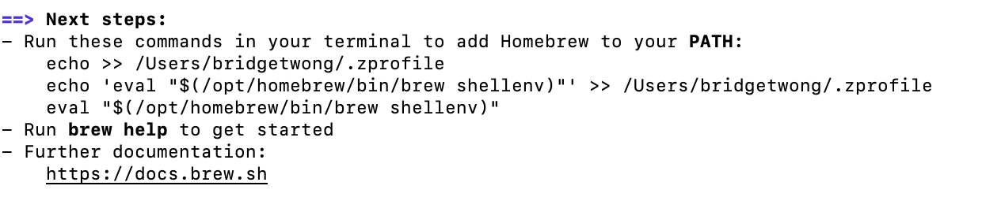
- Log into instance as normal.
- Run “sudo apt-get install lftp”
  - To access IGM server from instance
- Change to desired directory.
  - Ex. “Cd /data2/rs_256/rnaseq/mouse/fastqs/”
- Run “lftp -u username,password ftp server”
  - Ex. “lftp -u ferguson,bjHl5OPB3C ftp://igm-storage.ucsd.edu/250423_LH00444_0330_A22YW7JLT3/”
  - Will see the following
- Use mget and list all files desired separated by a space
- Type “bye” to leave lftp. Will return to instance again. Check for files. Should be in directory that you were in prior to connecting to the ftp server. Run “mv” to appropriate directory if necessary
- Run “md5sum filename”. Output will be a 32 character string that should match the md5sum given by IGM. This confirms that there is complete download of the file from server to instance. If the md5sum does not match that of IGM, there was a problem with downloading.

STEP 1.5: fastQC
- Create a new folder corresponding to where you would like all the QC files to go – i.e. “fastQC_reports”
- Run “fastqc -o fastQC_reports inputfile.fastq.gz” for an individual file or “fastqc -o fastQC_reports *fastq.gz” for all the files at once. It should take around 2-3 minutes to process each fastq file
- To collect these into a combined report, “conda activate base” then “multiqc fastQC_reports”

STEP 2: Align the RNAseq files
- Go to the RNAseq directory through: “/data2/rs_256/rnaseq ”
- Then, “cd mouse” to process mouse files and “cd human” to process human files.
- Open and edit: “22322_fqs.txt”
  - Input the prefixes of the RNAseq fastq files
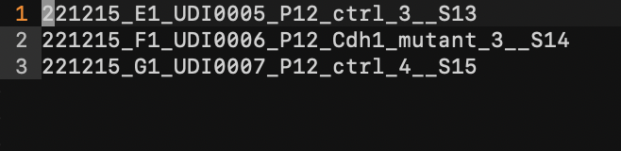
    - Ex. Full file name = “221215_E1_UDI0005_P12_ctrl_3__S13_L002_R1_001.fastq” then the prefix would be “221215_E1_UDI0005_P12_ctrl_3__S13”

    - You can input multiple files at once, and you just need to put in “R1” strand.
- Change back to ~/data2/rs_256/rnaseq/mouse directory (or human if processing human files).
- Run “conda activate rnaseq”
  - This allows STAR to be used.
- Open/Edit/Check “align_reads.sh” to make sure that the file path and the fastq suffixes make sense and align properly otherwise you will get an error.
  - If the files end with “L002_R1_001.fastq” then make sure that the suffixes in the code match for R1 and R2. If they do not, edit the script so that it matches.
  - Troubleshooting Tip: If an error appears and the files cannot be opened/read, check this script to make sure that the file paths for everything are correct. I.e. “ ~/rnaseq/mouse/index/ ” or
“ ~/rnaseq/human/index/ ” depending on the files you are processing.
  - “align_reads.sh script” function: Takes both sequencing files and aligns them to the transcriptome using STAR aligner. If you look through the script you can see that it goes into the /rnaseq/fastqs/ directory and takes both the R1 and R2 fastq files that correspond to one sample.

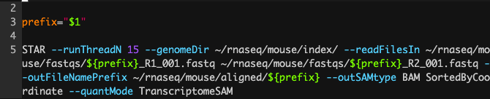
- Note: “/fastqs” changed to “/fastqs/RNAseq/” because this is folder where Challana stored fastq files

- Run “sh ./run_alignments.sh”
  - Troubleshooting Tip: If an error appears and the files cannot be opened/read, check this script to make sure that the file paths for everything are correct. You may have uploaded your data into home/ubuntu/rnaseq instead of data2/rs_256/rnaseq
  - More Troubleshooting: If an error stating that there was a FATAL ERROR appears, it is likely that there is not enough space in the instance, which means that you need to do each file individually and delete as you go, or make more room in the instance. Essentially, if the error states that the expected bin size is around 10 GB and there are 46 bins, then you might need more space on the instance. For example…

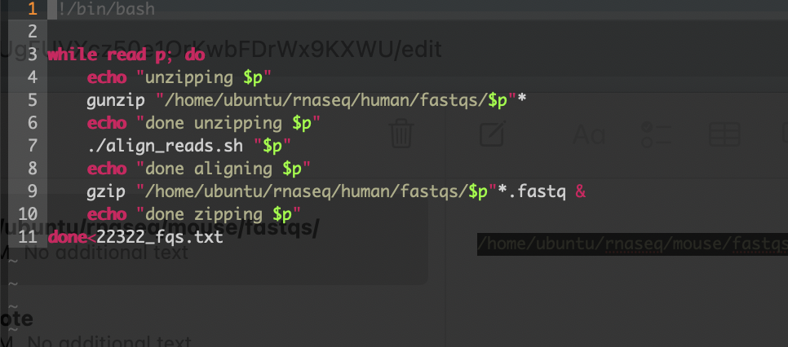
  - “sh ./run_alignments.sh” function: Automates the unzipping of fastq files and then references the align_reads.sh script which maps the sequencing reads to the transcriptome of the mouse using STAR to generate a BAM file. Then it will zip the fastq file again.

- When script is finished running, cd ~/rnaseq/mouse/aligned
- Then, “conda deactivate”
  - If you are still in the conda activate rnaseq environment

STEP 2.5: QC on alignments
- Create a new folder corresponding to where you would like all the QC files to go – i.e. “QC_alignments”
- Run “fastqc –outdir QC_alignments inputfile.sortedByCoord.bam” for an individual file or “fastqc –outdir QC_alignments *sortedByCoord.bam” for all the files at once. It should take around 2-3 minutes to process each fastq file
- To collect these into a combined report, run “conda activate base” and “multiqc QC_alignments”

To align with Salmon:
- Enter “cd /data2/rs_256/rnaseq/mouse”, although a salmon index should already be built in this directory and ~/rnaseq/mouse.
- Run “conda activate salmon”
- Run “./salmon_quant2.sh” and then enter the path/to/directory/name of the R1 file but without “_R1_001.fastq.gz”
  - I.e. ./salmon_quant2.sh 240822-A9-UDP0065-P9-Fig4NesCre-ctrl-1-S35_L007
- Files should now be in salmon_quant_output; export the .quant file

STEP 3: Generate the BigWig Files
- Enter “conda activate base”
  - This allows you to use bamCoverage.
- Edit the “ create_bw.sh ” script to input all of the bam files that you want to be converted into bigwigs.
  - Two different types of bam files are generated from the run_alignments.sh script.
  - You want to convert the bam file that ends in “sortedByCoord.out.bam”
- Run “ ./create_bw.sh ”
  - ./create_bw.sh function: Takes all of the sortedbyCoord.out.bam files that you list and converts them all to bigwigs using bamCoverage.
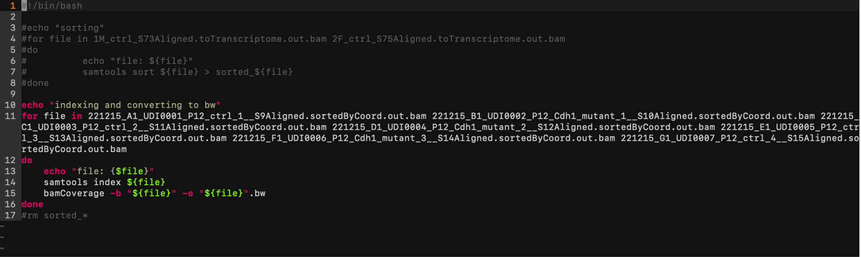

STEP 4: Export out the “...sortedByCoord.out.bam.bw” files
- Log out of the instance (type logout)
- Type in: “ scp -r -i ./210323.pem ubuntu@ec2-35-167-35-96.us-west-2.compute.amazonaws.com:/data2/rs_256/rnaseq/mouse/aligned/name of sample that ends with.bw . path/to/local/directory”
  - Make sure that the ec2 address is the current one.
  - Change the “:/data/…” part to wherever the file is actually located. (i.e. if it is located in human directory, change it so what it is human_workdir)
  - AFTER THE BW FILE, MAKE SURE THAT IT IS “.bw[space].[space] “ → enter

Files that can be cleared:
The STAR alignment program generates a bunch of intermediate files during the process. If something goes wrong and you would like extra details about it, you can export them out as txt files to see what went wrong. If the “sortedByCoord.out.bam” file was processed successfully, then you can delete them to clear up space.

If you get a FATAL ERROR during the BAM generation process and the process terminates itself (i.e. the files do not finish processing, ~/rnaseq/mouse/aligned will store an intermediate and not necessary [FILE NAME] STAR.tmp directory (in purple), meaning the process didn’t finish. If STAR runs successfully, the tmp file is supposed to be deleted automatically. Before re-running the pipeline, delete that directory by using rm -r as you may still get an error if you do not. You can also delete the intermediate files as it may be confusing afterwards. If you want to check that the files are processed successfully, check to make sure that the “...sortedByCoord.out.bam” is reasonably large (and not 0). The rest of the intermediate files are supposed to be small. If the BAM file is small (likely 0), re-run the pipeline.

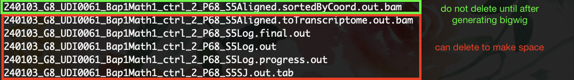

To check quality of fastq file, use:
→ head -n 40 ~/rnaseq/mouse/fastqs/${prefix}_R1.fastq
To check quality of BAM file, use:
→ samtools quickcheck ~/rnaseq/mouse/aligned/${prefix}Aligned.sortedByCoord.out.bam

featureCounts
Purpose: Generate the number of reads (counts) that got assigned to a specific gene.
- cd /data2/rs_256/rnaseq/mouse/aligned
- Run the following command
- Exons Only
featureCounts -p -T 8 -t exon -g gene_id -a /data2/rs_256/rnaseq/mouse/gencode.vM10.annotation.gtf -o counts_kelly/NameofFile.txt NameofBAMfile

- All Genes
featureCounts -p -T 8 -t gene -g gene_id -a /data2/rs_256/rnaseq/mouse/gencode.vM10.annotation.gtf -o counts_kelly/NameofFile.txt NameofBAMfile

- For multiple files:
for file in *.sortedByCoord.out.bam; do
featureCounts -p -T 8 -t exon -g gene_id -a /data2/rs_256/rnaseq/mouse/gencode.vM10.annotation.gtf -o counts_kelly/${file%.sortedByCoord.out.bam}counts.txt $file
done
- What the commands mean:
  - -p = double- end read mode (pairwise)
  - - T 8 = dictates the number of threads that is run
  - -t exon = only run counts for exons (not introns) → -t gene = include introns
  - -g gene_id -a /data2/rs_256/rnaseq/mouse/gencode.vM10.annotation.gtf = what the reference file is for annotation
  - x-o counts_kelly = directory where you want the count files to be stored.
  - NameofFile.txt = what you would like the file to be named
  - NameofBAMfile = the name of the BAM file with the counts
- Download the summary and the counts.
  - Command: “ scp -r -i ./210323.pem ubuntu@ec2-35-167-35-96.us-west-2.compute.amazonaws.com :/data2/rs_256/rnaseq/mouse/aligned/countsdirectory/name of file . path/to/local/directory”
- Check for the expected number of assigned reads:
  - With rRNA depletion, the minimum should be around 20%, but expect between 50 - 60% at the exon level. Expect 75-80% at the gene level.
  - Without rRNA depletion, expect between 80 - 90%.

